Herbal Dog Intake Form Date ____________

Name _____________________________ Age________ M / F Spay / Ntr
Weight ____________ Size/build _______________________
Breed(s) ____________________________________________________________
Coat/Color(s) ___________________________________ Eye color ___________
Vaccines / Dates _____________________________________________________
Meds _______________________________________________________________

Caretaker’s name ____________________________________________________
Phone_______________________ email_________________________________
Address____________________________________________________________
Vet or other healthcare provider ___________________________________________________________________
Health history ______________________________________________________________________________________________________________________________________
___________________________________________________________________
Diet______________________________allergies___________________________
Current health issues / symptoms and concerns _________________________________________________________________________________________________________________________________________________________________________________________________________
Time of best/worst symptoms__________________________________________
Triggers for symptoms_________________________________________________
When did symptoms begin? ___________________________________________________________________
What gives ease? ___________________________________________________________________
What does caretaker think? ______________________________________________________________________________________________________________________________________
Any test results_______________________________________________________
Exam
Tongue___________________________ Teeth/gums/mouth__________________
Pulse rapid >180 ________ slow>80 Warm/cold moist/dry tense/relaxed
Respiration/ panting___________________
Coat and skin ______________________ Gait ________________________
Discharges______________________________________________________
Mood changes ___________________________________________________
Suggestions and Protocol __________________________________________________________________________________________________________________________________________________________________________________________________________________________________________________________________________________________________________________________________________________________________________________________________________________
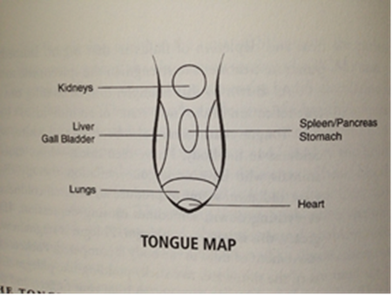

SAFE for Dogs
Alfalfa – cancer prevention, arthritis, growing puppies
Aloe – topical
Basil/tulsi – anti-viral, anti-microbial, digestive, anti-fungal; fresh chopped on food
Burdock – arthritis, liver, immune, skin, back problems
Calendula – skin
Catnip – nervine, motion sickness, carminative
Cayenne – heart, nerves, arthritis
Chamomile – calms hyperactivity, GI, topical
Comfrey – use with caution
Dandelion – diuretic, liver; flowers for lecithin
Echinacea – immunity, pain, anti-toxin
Eyebright – eye/conjunctivitis, allergic reactions
Flax seed – EFA’s skin and brain, cancer
Garlic – (in moderation)
Ginger – GI, circulation, pain and nausea
Ginkgo – circulation
Hibiscus – cooling, hydrating.
Licorice – cough, Addison’s, skin, anti-viral
Mallows - emollient
Milk thistle – liver, pancreatitis, leptospirosis
Mullein leaf – respiratory, cough: Root – back
Neem – leaf – (not in pregnancy), topical for fungal, anti-microbial, parasite
Nettle – allergies, anemia, rinse for skin
Okra – emollient, fiber, cooling
Parsley – UTI
Peppermint – radio-protective, no reported toxicity but avoid very high doses.
Red clover – skin, coughs, cancers
Rose
Rosemary – high in iron, anti-oxidant, warming, ptsd
Sage – gingivitis
St. J’s wort - gloom
Sarsaparilla – dry skin, arthritic conditions.
Skullcap – anti-epileptic, relaxant, calming, anodyne
Slippery elm
Valerian
Yellow dock

